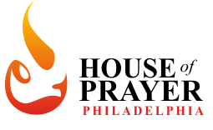

Leadership Approval Process

- Intercessors:

- Must complete the Harp and Bowl training at least once.
- Must complete intercession training.
- Must sit on to observe and be coached by an intercessor for a minimum one week.
- Become approved.

- Musicians/Singers:

- Must complete the Harp and Bowl training at least once.
- Complete an audition.
- Shadow set for minimum one set.
- Sit in as second or third singer (For singers) or play with another musician as a back up (For Musicians) for 2-3 weeks.
- Become approved by worship leader to play on set.

- Worship Leader:

- Same as musicians +
- Must be approved musician and singer
- A minimum of 3 months in any House of Prayer (References Required)

